- S3 bucket 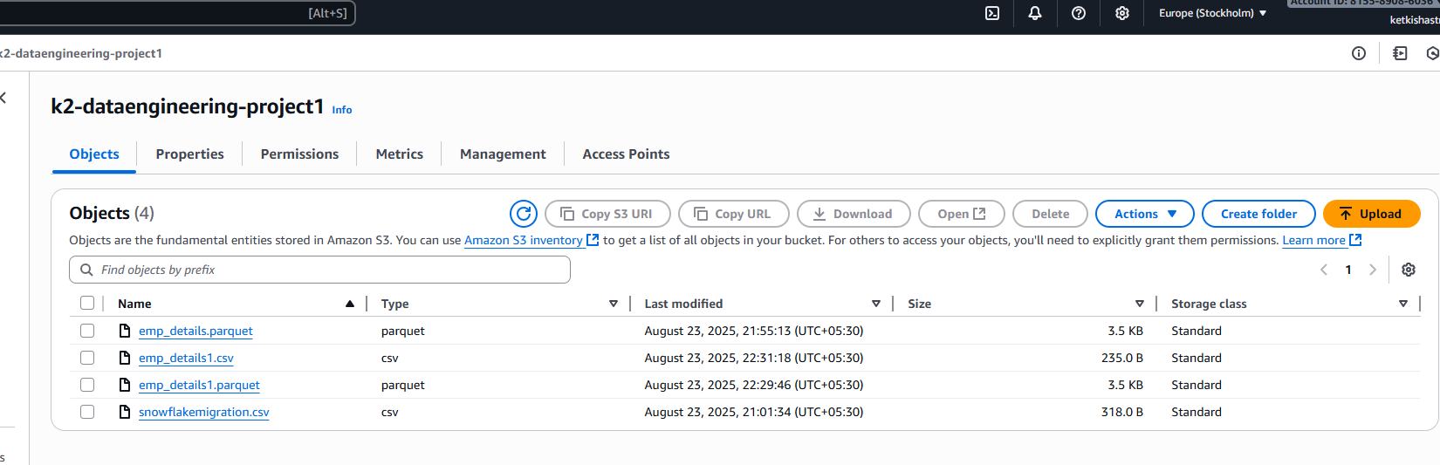
- GCP job
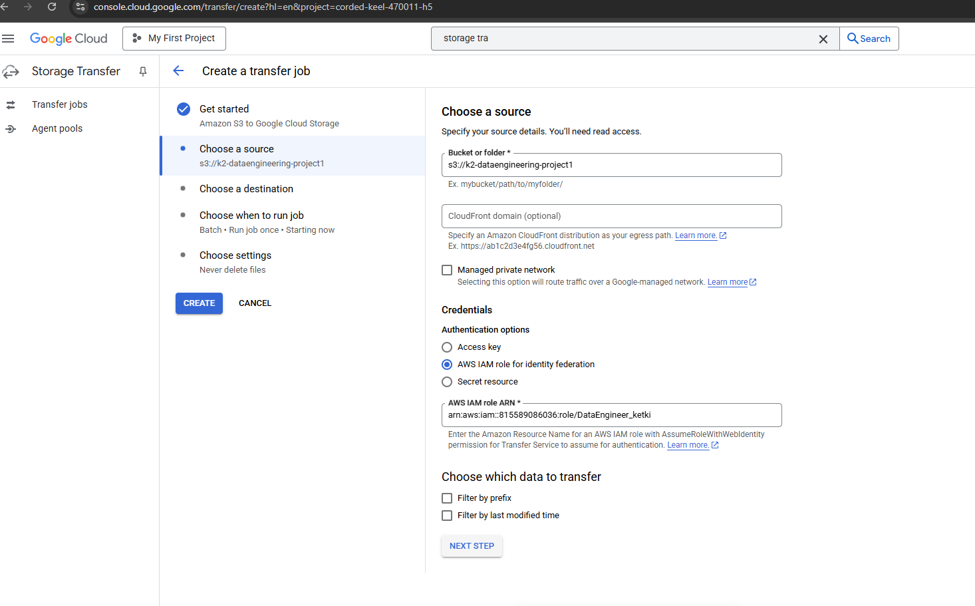
- Job run successfully.

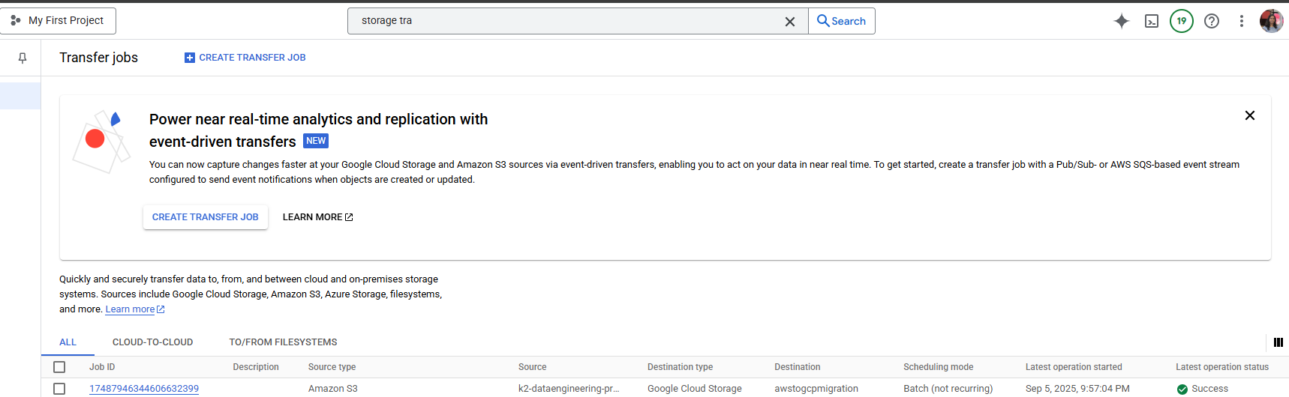

- Files transferred to GCP bucket
